**Test Plan**

Project: Pet Store

## Version History

|  |  |  |  |
| --- | --- | --- | --- |
| Date | Version | Author | Comment |
| 19/07/2022 | 1.0 | Carolina ceballos | Development of Test Plan |

## Index

1. Introduction
   1. Scope
   2. References
   3. Glossary
2. Test context
   1. Project
   2. Test items
   3. Test Scope
   4. Out of test Scope
   5. Infrastructure
      1. Hardware base System
      2. Software base elements in the test environment
   6. Assumptions
3. Risks
4. Personal
   1. Means

## 1.Introduction

Ensure the development complying with the functional requirements defined by the client as well as the strategies for the fulfillment of the testing process, identify failures in early stages to avoid cost overruns in the Project, apply good practices for the design and execution of tests collect the data on the proposed metrics and make future decisions, identify the most common failures to provide feedback to the team and avoid them in future developments, detect the largest number of failures to deliver a quality product before putting it into production.

1.1. Scope

Build the Backend of an ecommerce to offer the adoption of pets. There will be 3 main modules.

1.2. References

* Project requirements specifications
* ISO 29119

1.3. Glossary

* UAT: User Acceptance Test

## 2. Test context

## 2.1. Project

The pet shop has 3 main modules:

1. Pet – All about pets.
2. Store – Purchase Orders.
3. User – User operations

## 2.2. Test Items

Test are performed on the following elements:

* **Pet –All about pets.**
* **Store –Purchase orders.**
* **User – User operation**

Backend test will be carried out in the aforementioned modules.

## 2.3. Test Scope

Next, the scope of the Sprints to be developed following the Testing process is defined:

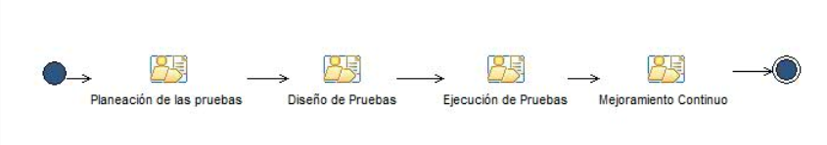

**Illustration 1 Software testing process**

As shown in Figure 1, the company´s testing process is divided into four stages.

* **Test Planning:** This phase of the process includes activities such as the definition of the testing approach for all phases, as well as the planning of time, work teams and the definition of the test environments.
* **Test design:** For this phase, the activities that encompass the design of test cases and their expected results are developed. In this phase, the test cases to be automated or scripts are also specified (see Illustration 2).

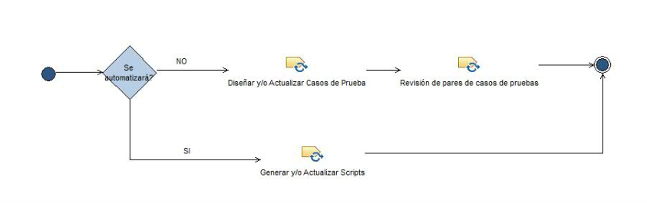**Illustration 2 Design stage detail.**

* **Execution of tests**: in this phase of the testing process, the execution of the tests and comparison of the results are carried out. In addition, the incident report if any.

**• Continuous improvement:** This phase of the process consists of the control of the activities that cover all the phases of the testing process.Each stage with the respective activities will be developed according to the work defined in the test plan where a relation is made by functionality to the stage executed below.

**1.** The planning, design and execution of Backend tests will be carried out on the modules mentioned in point 2.2 of the Test Plan with Postman.

**2**. Planning, design and execution of functional tests: system and integration on the web application

**3.** Planning, design and execution of automated E2E tests on the Pet Store APP application with Postman, unit tests on services with Selenium.

**2.4. Out of range**

Non-functional Quality factors such as performance, IT security, and usability will not be tested in this test plan. The company must define the person in charge to carry out these tests; likewise, the Front End will not be tested, and the other two modules

**2.5. Means**

**2.5.1. Hardware Base System**

The following table presents the hardware system resources employed in the testing efforts within this Test Plan.

| **Resource of system** | | |
| --- | --- | --- |
| **Resource** | **Quantity** | **Name and Type** |
| Computer with internet access | 1 | Windows 10 Home |

**2.5.2. Software base elements in the test environment**

**The following are the base software elements that are required in the test environment for this Plan.**

|  |  |  |
| --- | --- | --- |
| **Software Item Name** | **Version** | **Type and other notes** |
| **Maven** | 3.8.6 | Dependency Manager |
| **Gradle** | 7.5 | Dependency Manager |
| **Git** | git version 2.36.1.windows.10 | versioning system |
| **Java** | version: 1.8.0_333 | Programming language |
| **Pet store** |  | **App web /pet/** |
| **Postman** | V.9.4 | API automation tool |
| **Karate** | V. 2.2.3 | Android APK |
| **Rest Assured** | V. 3.0.2.3 | Test functions and HTTP responses |

## 2.6. Suppositions

Suppositions.

## • The test environment will be in Staging so that we can simulate when the client enters Information.

## • The Daily must be held at 11 am for Cross schedules with team members.

## • Unit tests must be done previously.

## • Unit tests cover 98% of the code.

## 3. Risks

|  |  |  |  |  |  |  |
| --- | --- | --- | --- | --- | --- | --- |
| ID | Risk factor | Risk | Probability (High - Medium - Low) | Impact (High - Moderate - Low) | Severity (Chance per impact) | Mitigation plan |
| R1 | Team rotations | If there is a high turnover in the team, there will be a loss of productivity due to on boarding and adaptation | High | Moderate | High | Negotiate team hours to completion |
| R2 | Team QA | The QA team is junior and does not have the experience. | High | High | High | Training and continuous support to the team |
| R3 | Implementation | Feature Implementation Delays | Moderate | Moderate | High | Evaluate the development of functions and replan according to progress |

*\*\*\* plantilla tomada del libro Agile Testing de Lisa Crispin y Janet Gregory.*

---------------------------------------------------------------------------------------------------------------------------

## Team

## Team QA

|  |  |  |
| --- | --- | --- |
| Tester | % Participation | Seniority |
| Carolina Ceballos | 100 | Junior |

## 